# **Project Plan**

**Project Name:** Ava

**Project Sponsor:** Will Hutchins (Application Infrastructure Solution Manager at Avanade)

**Project Team Members:**

**Name Email Role**

|  |  |  |
| --- | --- | --- |
| Julian Boss | bossj@uw.edu | Project Manager, Developer |
| Jessica Kuelz | jmkuelz@uw.edu | Designer, Developer |
| Bruce Shu | shuchangbruce@gmail.com | Developer |
| John Yun | johnyun@uw.edu | Designer, Developer |

**Problem Statement:** How might we improve customer service so that Avanade and their clients can ask and answer each other’s questions with quality and in a quick manner.

**Context:** Avanade was founded by Accenture and Microsoft to focus on business technology solutions and managed services. Currently, navigating Avanade’s website for in-depth information about their services is not optimized and may take some time - which may be a problem when on-the-go to a meeting with a client. Avanade is partnering with our team to streamline the experience of finding necessary information on their website in a quick manner.

**Key Audiences:** Avanade Employees, Clients/Potential Clients

**Constraints/Risks:**

* Project must be completed by 2017
* Project may not be live on Avanade.com before the project deadline due to internal security reviews by Avanade.
* Team members have limited experience with Node/Bot Framework.

**Goals/Outcomes:**

* Produce a working text & voice-based bot that provides relevant answers about Avanade.com (except the career section).
* English as the primary language
* Ability to give feedback regarding the relevancy of responses
* Bot gets smarter the more it is used.

**Resources/Tools:**

* Microsoft’s Bot Framework
* Azure cloud services
* LUIS (Microsoft’s learning AI)
* Skype
* Will Hutchins (Avanade)
* Microsoft Bot team

# **Project Timeline**

|  |  |  |
| --- | --- | --- |
| **Task** | **Start Date** | **End Date** |
| Project Planning | Fall, 2016 |  |
| Q&A pairs with Avanade | January, 2017 | February, 2017 |
| Familiarize group with Node | January, 2017 | February, 2017 |
| Meet with Microsoft Developers to learn Bot Framework | January, 2017 | April, 2017 |
| Prototype 1 of Bot | February, 2017 | March, 2017 |
| Add LUIS capabilities | April, 2017 | May, 2017 |
| *to be filled in as we get more information from sponsor |  |  |
| “” |  |  |
| “” |  |  |
| Write Implementation Documentation |  |  |
| Have working local standalone bot |  | May, 2017 |
| Publish to Avanade.com | June/July, 2017 | June/July, 2017 |

# 

# 

# **User Requirements**

|  |  |  |  |  |
| --- | --- | --- | --- | --- |
| Req. ID | Req. Title | Req. Detail | Req. Priority | Req. Status |
| 1 | English Language | The Bot should accept English questions and give English responses along with source URL | High |  |
| 2 | Voice Response | The bot should be able to interpret spoken language and give spoken language answers back | High |  |
| 3 | Response Feedback Collection | Users should be able prompted or persistent designed feedback for responses | High |  |
| 4 | Auto response curation | The bot should be able to use the relevancy responses and improve its answers. | High |  |
| 5 | Administrators response curation | Administrators should be able to provide customized responses for common or important questions | Med |  |
| 6 | Auto response  curation | Training plan for how to train the model | High |  |
| 7 | Auto response curation | The bot has the ability to determine the country of focus. Especially if it is looking for people. | Med |  |
| 8 | Voice Response | Skype Bot should be leveraged for voice enabled aspects | High |  |
| 9 | User Experience | Get me started nudge to prompt with some common questions | High |  |
| 10 | Response Curation | Accuracy reporting including top 10 best results and bottom 10 worst results | Med |  |
| 11 | User experience | Should be trained for some common jokes and looking up the weather, other silly questions | Low |  |
| 12 | User Experience | Best bets for most common questions | Med |  |

# **Competitor Matrix**

View full sized matrix:

<https://docs.google.com/a/uw.edu/document/d/1a1BzMpYCL4wCM6wQhjwz-pnQCYom6QkRDKRWnO4KT9s/edit?usp=sharing>

# 

# 

# **Personas**



**Name: Ken Smith**

**Occupation**: Consultant

**Hobbies**: skiing, boating, soccer, italian food

Ken is a consultant for Avanade who is onboarded on a couple of projects. While cutting it close when arriving to a meeting, he realizes that he needs a refresher on what specific services Avanade could provide for a particular business. Currently, his option is to call another team member or retrieve his project proposal



**Name: Dan Bush**

**Occupation**: Business Owner (Client)

**Hobbies**: Baseball, fishing, coffee, movies

Dan is a business owner who runs a warehouse fulfillment center. He is already a client with Avanade to update the current system into a more reliable & quick platform. Dan needs to find out information about his current service and what each option can do. Unfortunately, his consultant is unavailable and Dan needs to find this information to debrief his

managers in an upcoming meeting.



**Name: Jennifer Halloway**

**Occupation**: Small Business Owner (Potential Client)

**Hobbies**: Coffee, technology, music, wine, rock climbing

Jennifer owns a small technology store and is looking for some help with upgrading the store’s technology. She doesn’t know who to ask, so she’s been doing her research about different consulting firms. However, she wants to find more information before scheduling a meeting to see if their mission aligns with her business needs.

# **Storyboards**

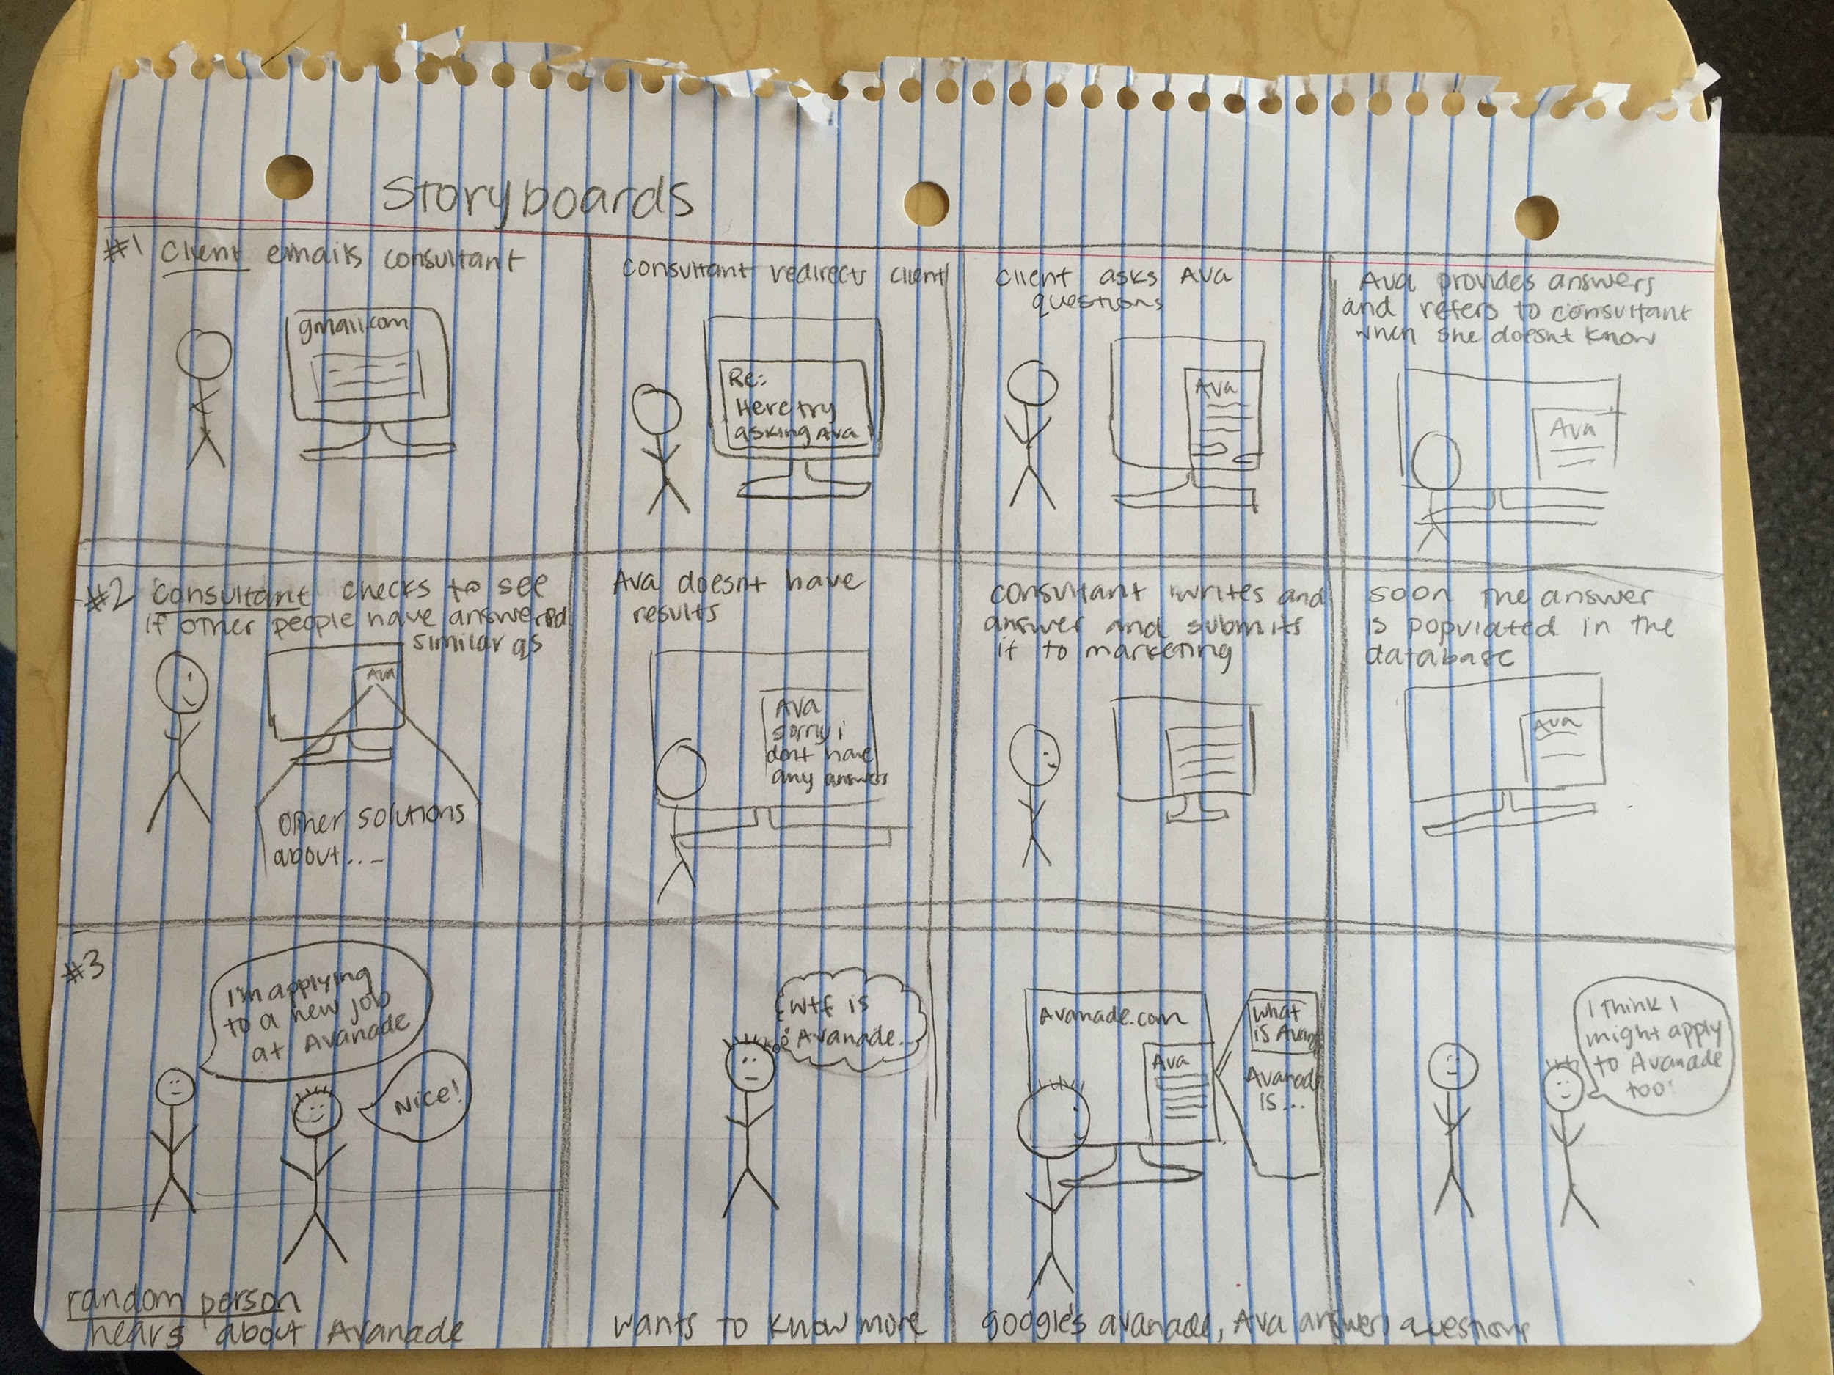

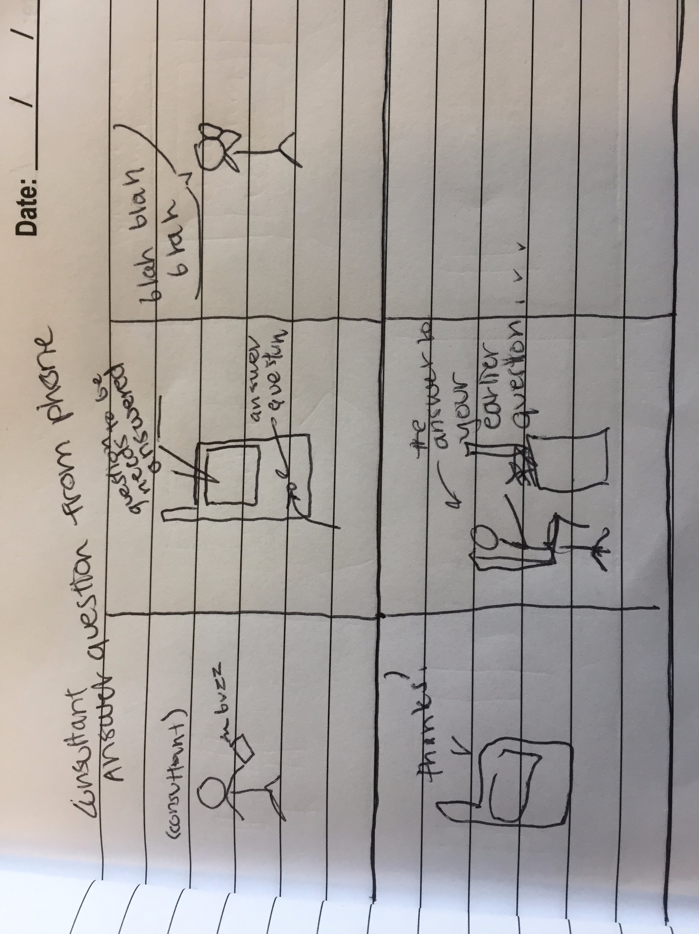

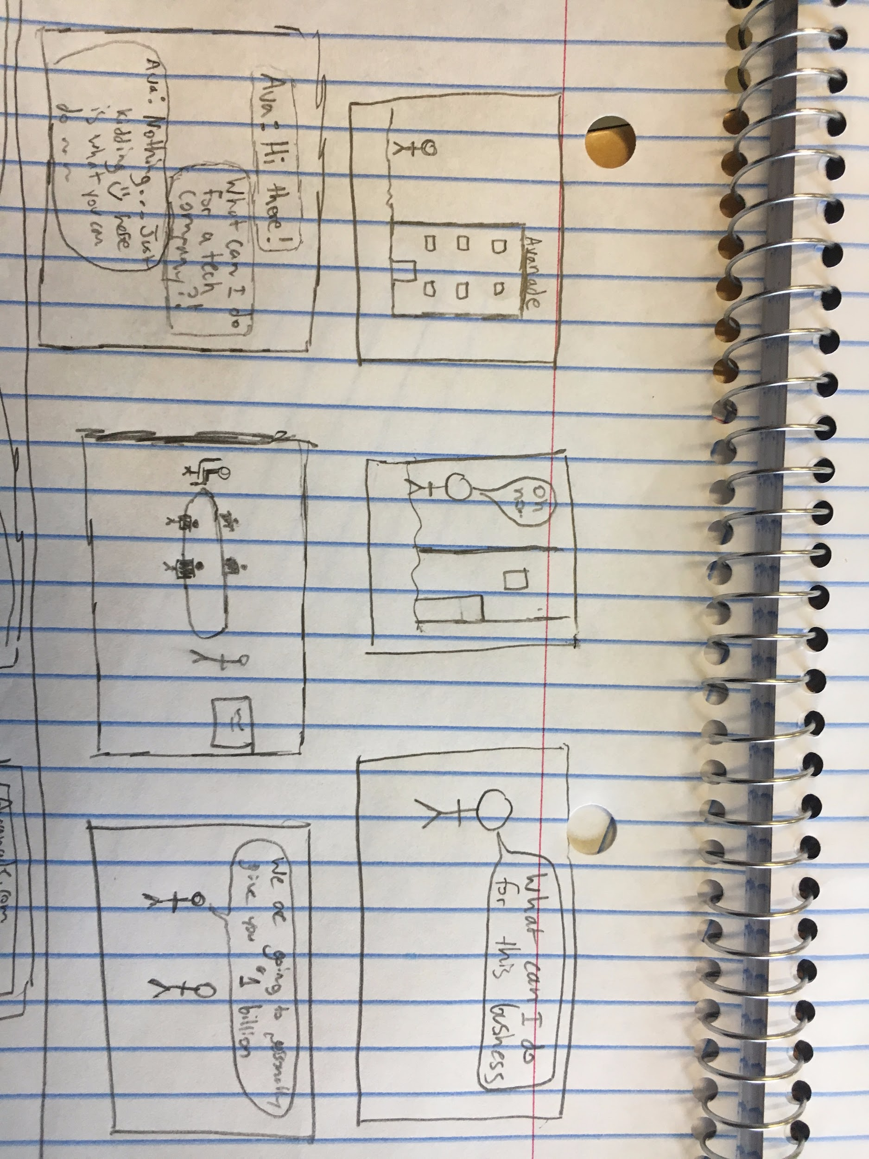

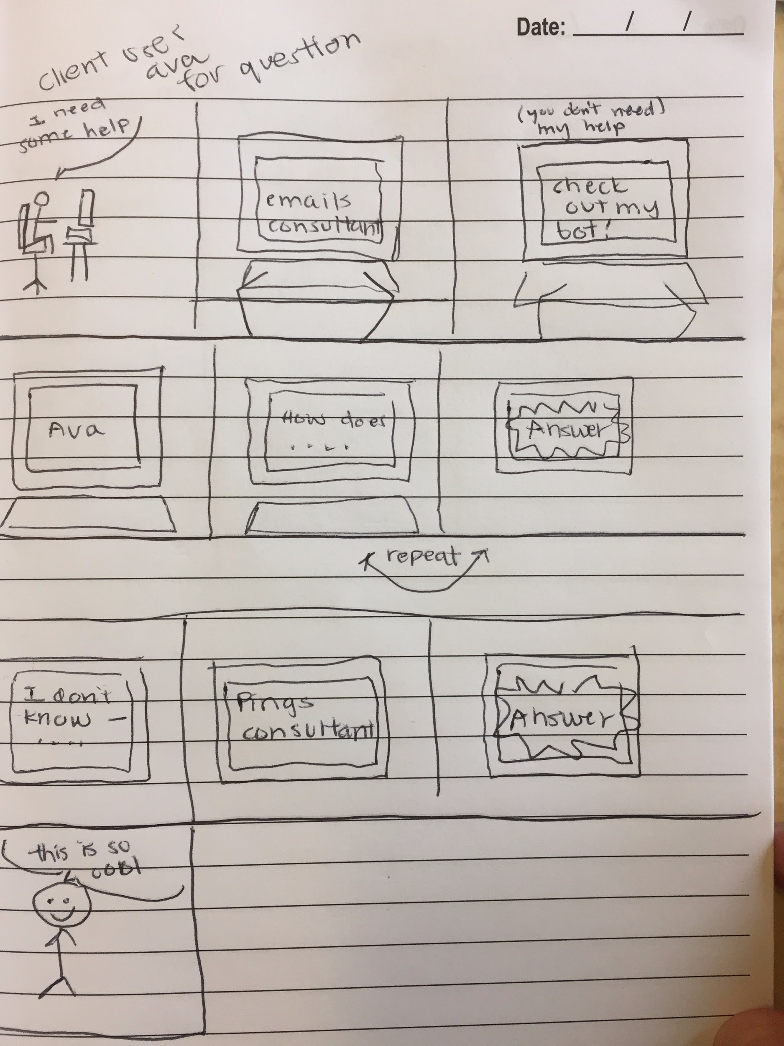

# **Team Agreement**

People are on the go and sometimes may not have the ability to browse a website. Running into a meeting with a potential client, specific information is needed fast about the latest Avanade solutions that was just released relevant to this deal. Avanade is partnering with the University of Washington to provide a bot to the Avanade.com website in order to streamline the experience of finding the necessary information to delight customers. This technology can also be used by sales, marketing as well as visitors to our website to drill down on specific questions. The goal is to provide the appropriate content based upon questions posed in natural language via text or speech! People find themselves in situations where text or voice may not be appropriate at a given time. The Avanade.com bot gets you exactly what you need fast.

We envision using Microsoft’s bot framework along with a Skype bot and hosting it in Azure either via newly available Bot as a Service or Azure Web Application. We also envision a Bot that gets smarter the more it’s used to ensure our Bot can mature along with our content on our site. For this we anticipate that the Language Understanding Intelligent Service, or LUIS to be included in the solution.

1. STRENGTHS OF TEAM MEMBERS

|  |  |  |
| --- | --- | --- |
| Team Member | Self-Assessment | Responsibilities (can change) |
| Julian Boss | **Experience:** microsoftbot framework  **Expertise:** communicating, presenting, project management  **Gaps:** coming to class | Organization and planning.  Microsoft FUSE/Avanade contact.  Microsoft Bot Framework.  LUIS training model. |
| Jessica Kuelz | **Experience:** Design, agile, teamwork, communication  **Expertise:** AWS  **Gaps:** coding knowledge/best practice, punctuality | Automated response curation.  Response reporting.  User Experience - client side |
| Bruce Shu | **Experience:** development  **Expertise:** Node.js, AWS  **Gaps:** UX | Microsoft Bot Framework.  Node to web implementation.  Backend response feedback collection. |
| John Yun | **Experience:** project management, design,  **Expertise:** communication, collaboration, creating relationships, conflict management  **Gaps:** minimal experience with all frameworks needed, best practice | Voice response (Skype endpoint API).  Administrator response curation.  User Experience - admin side |

1. TEAM-LEVEL TASKS

* Learn Frameworks
  + Learn Node.js
  + Learn Microsoft Bot Framework
  + Learn LUIS
  + Learn Azure
* Go to Microsoft HQ to learn the Bot Framework & Node implementation
* Weekly meetings with Will Hutchins (Sponsor)
* Coordination with Avanade teams for help with understanding their platforms.

1. TEAM EXPECTATIONS

* Come to class and team meetings on time.
* Come to class and team meetings with assignments and other necessary preparations done.
* Ask questions when we are not clear on expectations.
* Check/respond to messages promptly.
* Communicate thoughts and problems effectively.
* Stick to prepared timeline.
* Take on our designated role, and fulfil its expectations to the best of our ability.
* Divide work equally between ourselves.
* Show up to weekly meetings

1. COMMUNICATION GUIDELINES
   1. Facebook messenger
   2. GitHub
   3. Weekly meetings (Skype/in-person)
2. CONFLICT MITIGATION

* If a problem arises, speak up to the project manager (Julian). He is well-equipped to find a solution to interpersonal & project-related problems. If not, speak up to the team - if there is a problem, it is the whole team’s problem. We will figure it out together.
* If it is something out-of-scope for the project, communicate to the team so that we can contact the project sponsor (Will Hutchins) to notify him of the problem and to seek a resolution with Avanade’s team or gain support from different members.
* For technical operations/processes, our team has the support of various high-level teams (Microsoft Bot framework team, Head Bot framework manager, Avanade intern & technical groups).

1. ASSUMPTIONS

|  |  |  |  |
| --- | --- | --- | --- |
| **Assumption ID** | **Assumption Detail** | **Type of Assumption** | **Impact of Assumption going wrong** |
| 1 | Microsoft Cloud services or development frameworks will be used to develop the solution. | Software Platform | Unsupportable by Avanade |
| 2 | No authenticated content will be part of the solution. | Access to content | N/A our .com website is already unrestricted public data. |
| 3 | Solution can be executed stand alone or integrated into our Site Core solution. | Deployment | Difficult to manage and maintain platform post project |
| 4 | There is an operations guide for the platform so administrative staff knows how to support the solution. | Documentation | Difficult to manage and maintain platform post project |
| 5 | A Visio or PDF based diagram is produced that describes URLs, IP’s, DNS names, and all components of the system. | Documentation | Difficult to manage and maintain platform post project. Potential security review. |